**Name :** Payal Subhash Singh

# Linux Command Assignment

## Assignment :

The objective of this assignment is to familiarize yourself with the Linux command line by performing common tasks such as navigating the filesystem, manipulating files, and viewing file content.

## Execution :

1. Create a new directory called linux-assignment in your home directory.

**Ans :**

The mkdir stands for 'make directory'. With the help of mkdir command, you can create a new directory wherever you want in your system.

**Command:**

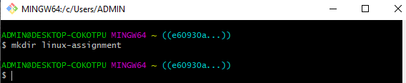

**Output:**

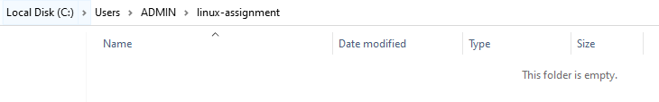

1. Navigate into the linux-assignment directory.

**Ans :**

Linux cd command is used to change the current working directory.

**Command**:

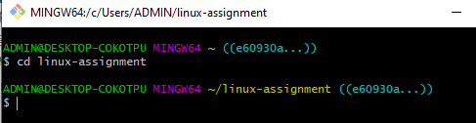

1. Create a new file called instructions.txt.

**Ans :**

It is used to create a file without any content. The file created using touch command is empty. This command can be used when the user doesn’t have data to store at the time of file creation.

**Command :**

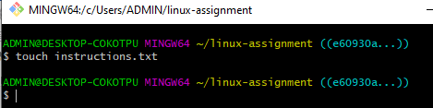

**Output :**

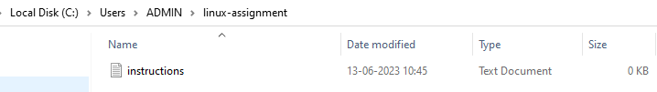

1. Write "Hello, World!" into instructions.txt using a command-line text editor like nano, vi, or emacs.

**Ans :**

GNU **nano** is a friendly and convenient text editor like vi and emac. It offers many other extra features like word searching, replacing, jump to a line or column, filename tab completion, auto-indentation, etc.

**Command:**

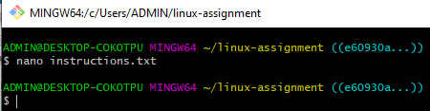

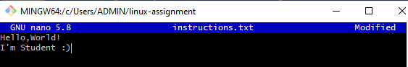

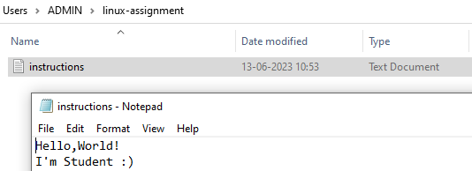

1. Display the contents of instructions.txt using a command.

**Ans :**

**Cat**(concatenate) command is very frequently used in Linux. It reads data from the file and gives their content as output. It helps us to create, view, concatenate files. So let us see some frequently used cat commands**.**

**Command :**

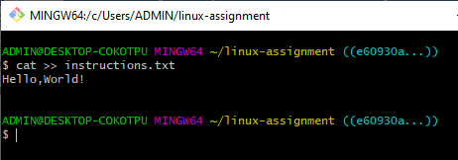

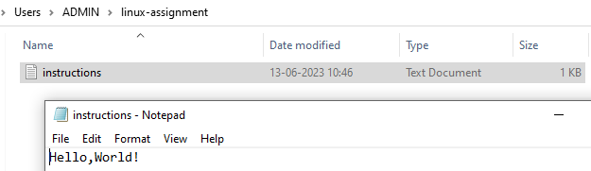

1. Rename instructions.txt to greetings.txt.

**Ans :**

**mv** command is used to move files and directories from one directory to another or to rename a file or directory**.**

**Command :**

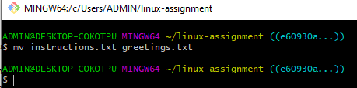

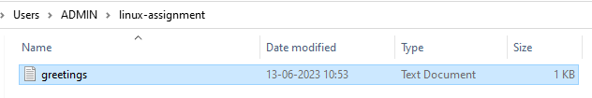

1. Copy greetings.txt to a new file called salutations.txt.

**Ans :**

**cp** stands for a copy. This command is used to copy files or groups of files or directories. It creates an exact image of a file on a disk with a different file name. cp command requires at least two filenames in its arguments.

**Command :**

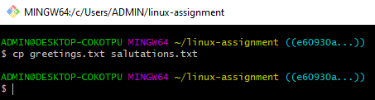

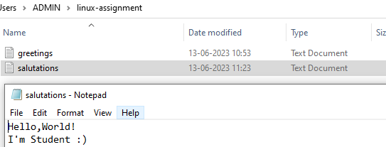

1. Delete greetings.txt.

**Ans :**

The rm command removes the entries for a specified file, group of files, or certain select files from a list within a directory

**Command :**

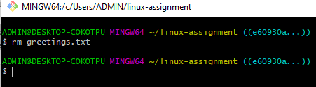

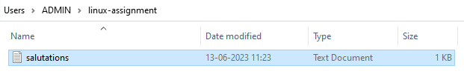

1. Create a new directory called archive.

**Command :**

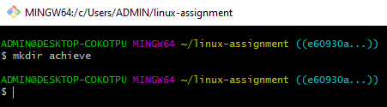

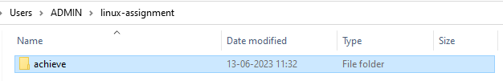

1. Move salutations.txt to the archive directory.

**Command :**

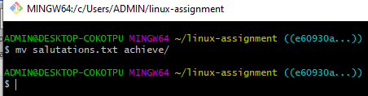

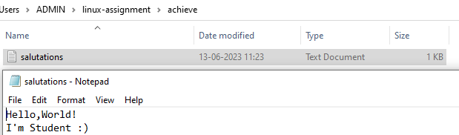

1. Display the current working directory to confirm that salutations.txt is now in the archive directory.

**Ans :**

The pwd command writes to standard output the full path name of your current directory (from the root directory)

**Command :**

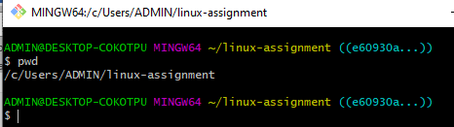

1. Navigate back to the linux-assignment directory and create three new empty files named file1.txt, file2.txt, and file3.txt.

**Command :**

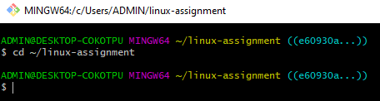

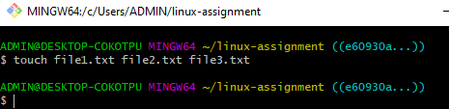

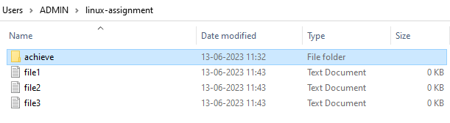

1. Display the list of files in the linux-assignment directory to confirm the creation of the new files.

**Ans :**

It is designed to list the names and features of files and directories.

**Command :**

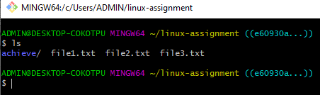

1. Create a new text file in your home directory named linux-assignment-commands.txt and write down all the commands you used in this assignment.

**Command:**

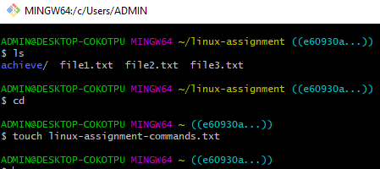

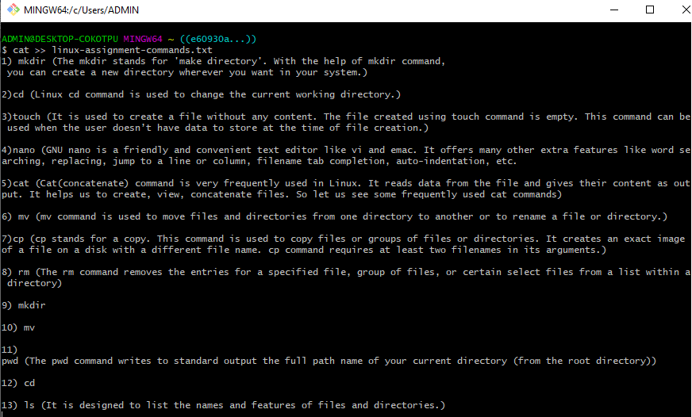

1. Share your linux-assignment-commands.txt file with your instructor or team lead for review.